Hotel Management System - Entity Relationship Diagram Documentation

The ERD
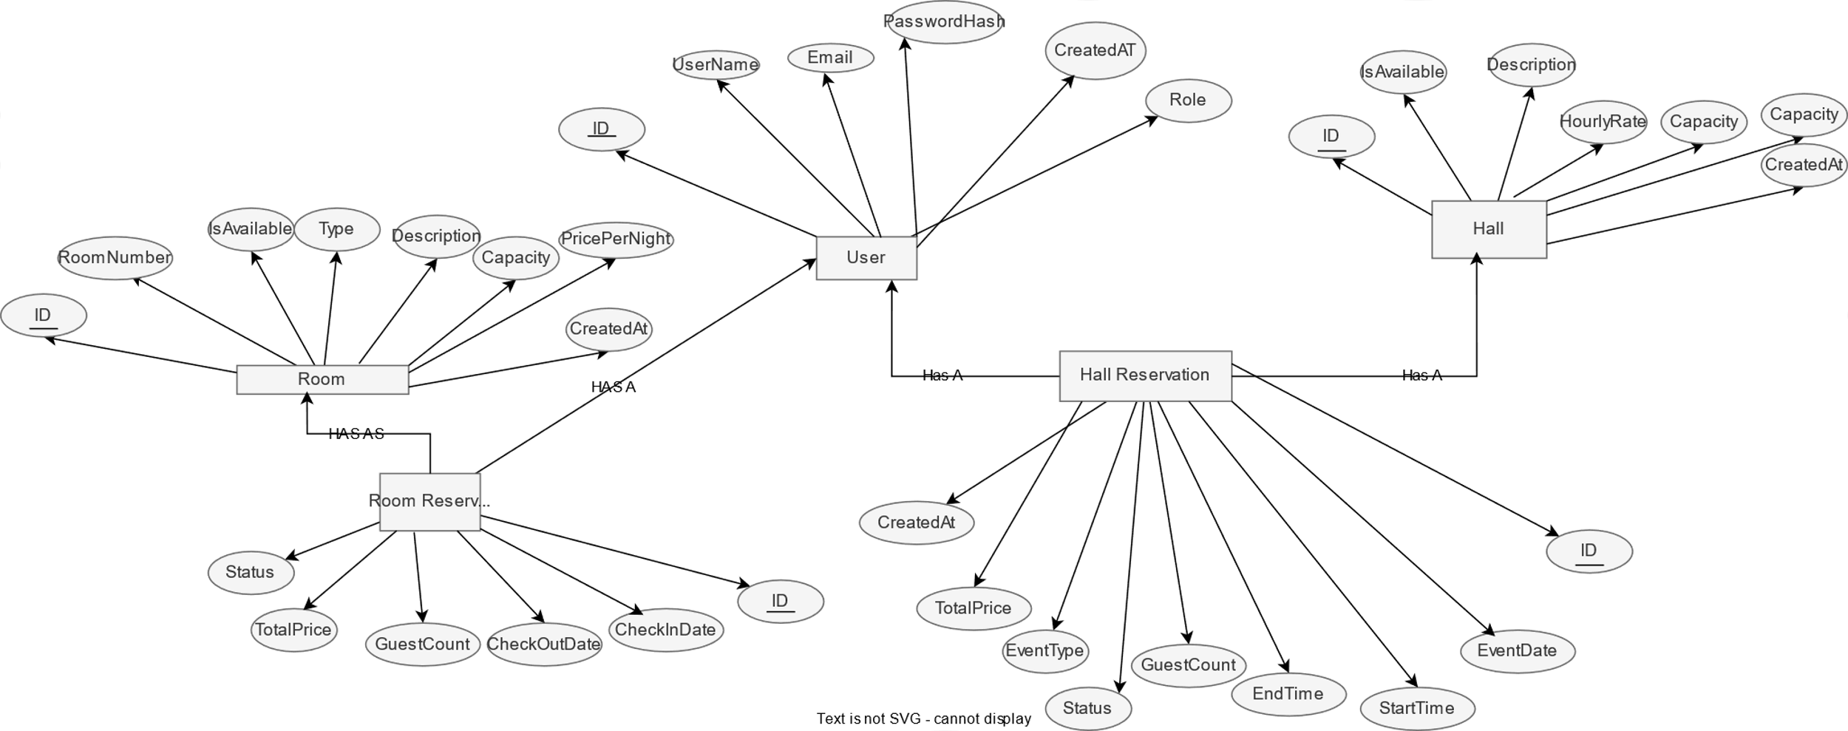

Overview
This Entity Relationship Diagram (ERD) represents a comprehensive hotel management system that handles both room accommodations and event hall reservations. The system manages users, rooms, halls, and their respective reservations with detailed attributes and relationships.

Entities and Their Attributes

1. User
Description: Represents system users including guests and administrators
- ID (Primary Key)
- UserName
- Email
- PasswordHash
- Role
- CreatedAT

2. Room
Description: Represents hotel rooms available for booking
- ID (Primary Key)
- RoomNumber
- Type
- Description
- Capacity
- PricePerNight
- IsAvailable
- CreatedAt

3. Hall
Description: Represents event halls available for reservation
- ID (Primary Key)
- Description
- HourlyRate
- Capacity
- IsAvailable
- CreatedAt

4. Room Reservation
Description: Manages room booking transactions
- ID (Primary Key)
- CheckInDate
- CheckOutDate
- GuestCount
- TotalPrice
- Status
- CreatedAt

5. Hall Reservation
Description: Manages event hall booking transactions
- ID (Primary Key)
- EventDate
- StartTime
- EndTime
- GuestCount
- TotalPrice
- Status
- EventType
- CreatedAt

Relationships

1. User Relationships
- User → Room Reservation: One-to-Many (A user can have multiple room reservations)
- User → Hall Reservation: One-to-Many (A user can have multiple hall reservations)

2. Room Relationships
- Room → Room Reservation: One-to-Many (A room can be part of multiple reservations over time)

3. Hall Relationships
- Hall → Hall Reservation: One-to-Many (A hall can be part of multiple reservations over time)

Key Features

User Management
- Supports different user roles (admin, guest, etc.)
- Secure authentication with password hashing
- User activity tracking with creation timestamps

Room Management
- Comprehensive room inventory with detailed specifications
- Availability tracking system
- Pricing based on room type and nightly rates

Hall Management
- Event space management with capacity details
- Hourly-based pricing model
- Availability status tracking

Reservation System
- Dual reservation types (rooms and halls)
- Date and time management for bookings
- Guest count tracking
- Financial calculations (TotalPrice)
- Status tracking for reservations

Business Rules
- Availability: Both rooms and halls have availability status that determines if they can be reserved
- Pricing:
  - Rooms use nightly pricing (PricePerNight)
  - Halls use hourly pricing (HourlyRate)
- Capacity: Both entities enforce capacity limits for safety and comfort
- Temporal Constraints:
  - Room reservations use check-in/check-out dates
  - Hall reservations use specific event dates with start/end times
- User Accountability: All reservations are linked to specific users

System Benefits
- Centralized Management: Unified system for both accommodation and event space management
- Financial Tracking: Automated price calculation for both room and hall reservations
- Availability Management: Real-time tracking of room and hall availability
- User-Centric Design: All reservations tied to user accounts for better customer management
- Comprehensive Reporting: Built-in timestamps for audit trails and reporting

